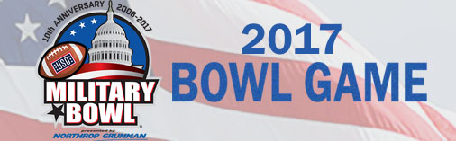

What: Military Bowl Watch Party: Navy vs. Virginia in Annapolis, MD

When: Thursday, December 28, 2017, 11:30 AM (Kickoff is at 12:30 PM Central)

Where: Coaches Bar & Grill, 9089 West 135th Street, Overland Park, KS 66223

Who: USNA Alumni, USNA Parents, and Veterans & Friends Navy/Marine
Corps- Greater Kansas City Metro USNA Alumni Chapter Host

Please come early and eat lunch, the food is excellent! You can order off their standard lunch menu. http://www.coach-s.com/food.html

We will have door prizes so please bring some cash to buy $1.00 raffle tickets. Similar to Army-Navy, we will raffle them off during the first half and at halftime. Wear Navy spirit wear.

We don’t do fundraisers, so chapter dues are critical to our financial success. We use those dues and the raffle monies to host events like this watch party, help our KC area Blue & Gold officers guide future USNA candidates and support local college career events. Jack Rush, chapter Treasurer, will be there if you want to pay your $25 2018 KC local chapter dues.

If you are not able to attend, please mail a check to Jack:
CDR Jack Rush ‘73, USNR (Ret.)
9632 Windsor Street, Leawood, KS 66206
Make checks payable to: Greater KC USNA Chapter

You still have time to RSVP, so please email me by December 20. Bob Culler
bob.culler@1974.usna.com or text 913 488-6319. Indicate the number in your party so we can get enough space.

Go Navy, Beat Virginia! - Go Navy, Beat Army!

Bob Culler
Bob Culler ’74, President, Greater Kansas City Metro Chapter

